1. Task – exploratory testing

The link of my Seamaster 2531.80 doesn't work (Page not founded)

Used device/browser:

* Version 100.0.4896.127 (64-bit) on Window 10

Steps to reproduce:

* Open the <http://www.007museum.com/> page
* Scroll down to the <http://www.007museum.com/omega_casino.htm> and click on it
* New page will be displayed
* Scroll down on link my Seamaster 2531.80 and click on it
* This link redirect to error page (Error 404)

Screenshot:

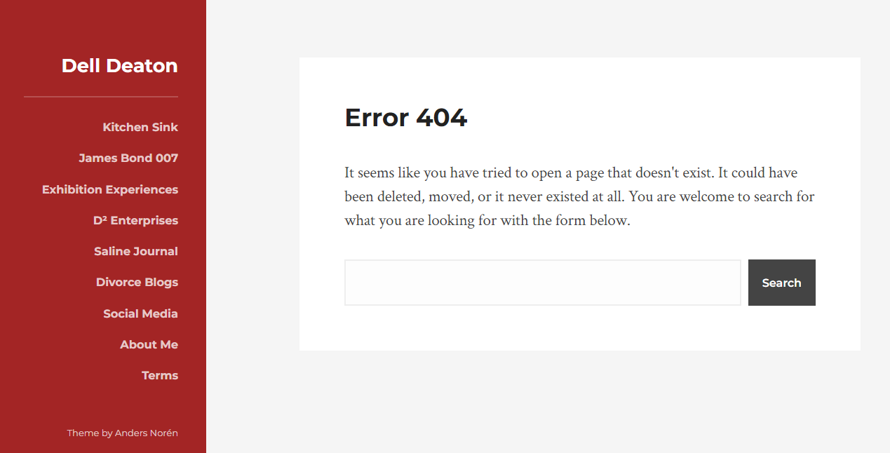

Instead of the regular site it opens facebook page of The Other Fellow

Used device/browser:

* Version 100.0.4896.127 (64-bit) on Window 10

Steps to reproduce:

* Open the <http://www.007museum.com/> page
* Scroll down to the bottom of the page to the James Bond documentary „The Other Fellow“
* Click on <http://www.theotherfellow.com/>
* Instead of the regular site it opens facebook page of The Other Fellow

Screenshot:



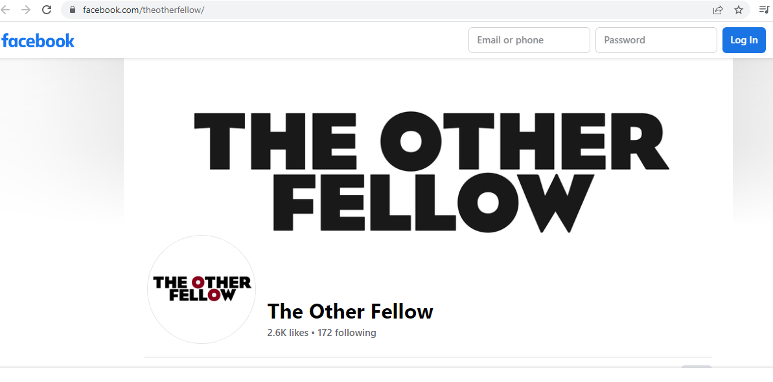

The company logo at the top of the ad doesn’t work

Used device/browser:

* Version 100.0.4896.127 (64-bit) on Window 10

Steps to reproduce:

* Open the <http://www.gatesnfences.com/index.html> page
* On the left side of the page click on Driveway Gates
* New page will be displayed
* Below the ad at the top of the page click on Receivers
* New page will be displayed
* The Chamberlain company logo at the top of the ad doesn’t work

Screenshot:

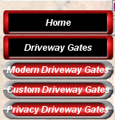

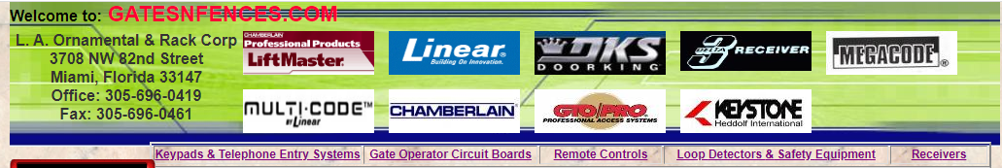

Instead of the correct page of the link, it opens the wrong page

Used device/browser:

* Version 100.0.4896.127 (64-bit) on Window 10

Steps to reproduce:

* Open the <http://www.gatesnfences.com/index.html> page
* Scroll down to the bottom of the page to Copyright
* Click on Links
* New page will be displayed
* At the top of the page, above the table is a link from all Directory <http://directory.classifieds1000.com/> and click on it
* Instead of the regular site it opens Lobby forum

Screenshot:

